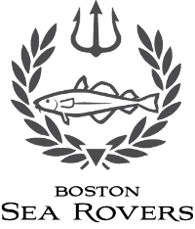
Boston Sea Rovers
Annual Summer Internship

Name: _____________________________________ Telephone Number: _______________________
Address: _________________________________________________________________________
City, State, and Zip Code: ___________________________________________________________
Date of Birth: ____________________
Citizenship: ________________ Place of Birth: ______________________
Cell Phone Number (if available: __________________________________
Fax Number: ____________________________ E-mail: ______________________________________
School Attending (w/address): ___________________________________________________________
____________________________________________________________________________________
If still in High School, please list the Colleges/Schools Applied to: ________________________________
________________________________________________________________________________________________________________________________________________________________________
Present Overall Grade Point Average (avg/baseline): ____________________
Primary Underwater Interests: ___________________________________________________________
____________________________________________________________________________________
How did you become aware of the Internship? ______________________________________________
____________________________________________________________________________________

______________________________________ _____________________________
Signature Date

Signature of Parent or Guardian if Applicant is a Minor, and by their signature they, on my behalf release all claims that both they and I have.

______________________________________ _____________________________
Signature Date

Boston Sea Rovers Annual Summer Internship
Candidate Diving History

Name: |  | Internship Year:
Date of Birth: | Phone Number:

Emergency Contact Information (Person to notify in case of emergency)

Name: | Home Phone:
Relationship: | Work Phone:

Training – Diving Courses & Related Training (medical, boating, etc.) Completed

Agency | Certification  Level | Date of Completion | Instructor Name  and Number
 | Open water (Basic)

Diving Experience

Number of Years: | Total Dives: | Total Hours:
Number of dives in last 12 months: In last 6 months: |  | Maximum Depth:
Number of dives by depth: 0 - 40 feet: 41 - 70 feet: 71 - 100 feet: 101 - 130 feet:

> 130 feet: .
Geographical locations in which you have dived:

Page 1 of 2

Please provide a short paragraph about your most memorable dive(s) and another discussing your immediate future dive plans (upcoming trip, training, etc.)

Enclose the following supporting documents with this application. Electronic copies are preferred but photocopies will be accepted.
- Copies of all pertinent certifications (front and back)
- Copy of dive log for the last 12 months

I certify that the above information is correct and that I agree to follow the safety regulations of the Boston Sea Rovers Internship Program and to abide by whatever limitations or restrictions may be imposed by the Internship Committee

_____________________________________ __________________
Signature Date

Signature of Parent or Guardian if Applicant is a Minor, and by their signature they, on my behalf release all claims that both they and I have.

______________________________________ _____________________________
Signature Date
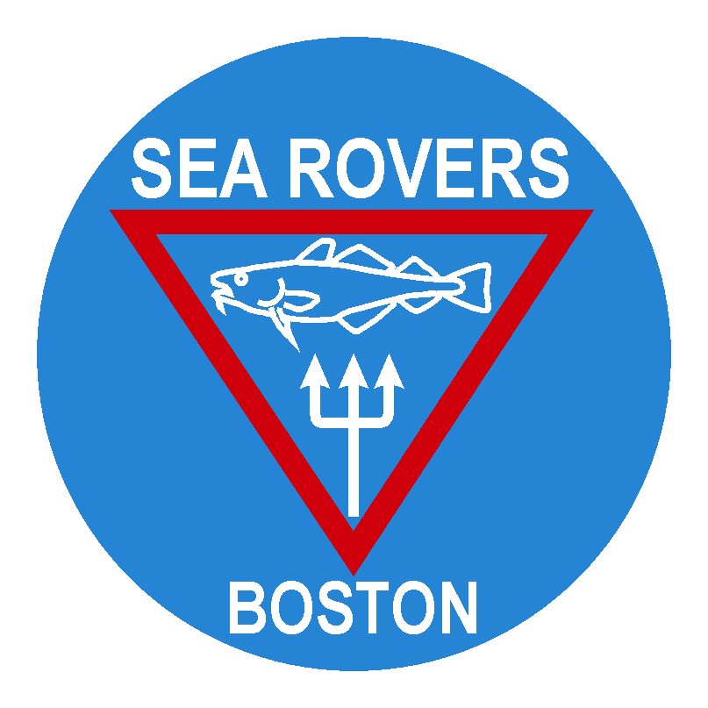
Boston Sea Rovers
Annual Summer Internship

APPLICATION CHECKLIST
- Application Form completed and signed
- Copies of both sides of all your scuba diving certification card(s)
- Copy of your dive log
- Official High School or College transcript(s)
- Completed medical questionnaire/health history and copy of most recent physical signed by a licensed physician. (Minimum requirement; all medical requirements must be met before final selection as Intern)
- A letter of recommendation from teacher from whom you have taken at least one class (Preferably physical and/or biological sciences)
- A letter of recommendation from person in your community (non-family member)
- Statement from scuba instructor or experienced diver regarding your diving proficiency
- Current resume / personal biography including any extracurricular activities
- Essay (maximum 2 pages, double spaced). Must include:
  - Why do you want to pursue a career in the underwater world
  - What do you hope to contribute to the underwater world and the Boston Sea Rovers?
  - What are your personal goals, and how will the Internship help you to achieve them?
Electronic submission of all materials is preferred.

PERFORMANCE BY THE INTERN
Interns must attend the Boston Sea Rovers Annual Clinic during the year of selection and the following year. During the summer, the Intern is required to keep diving and personal logs and to capture photographic images that chronicle personal impressions of their experiences. At the end of the summer, the Intern is expected to prepare an evaluation of his or her educational and career goals as they may have been altered by the Internship. This self-evaluation, along with a chronology of the activities, is reflected in a required final presentation to the Sea Rovers Board of Directors as well as in one or more audiovisual presentations given by the Intern at the following Marine Careers and Ocean Sciences Symposium conducted in association with the Boston Sea Rovers Annual Clinic.

REQUIREMENTS
To be eligible for the Scholarship, the applicant must:
- Be a certified scuba diver
- Demonstrate familiarity with the Boston Sea Rovers and the Annual Dive Clinic
- Live in the greater Boston/New England area during the summer
- Maximum age of 19 at the time of the application deadline (June 30)
- Interns must be at least 18 years old by the beginning of their Internship
- Be on track to graduate with a high academic standing in a nationally accredited high school program by June of the Internship year or attending college at the time of application
- Have the ability to pass a diving fitness medical examination using the form provided (not necessary for the deadline, but required prior to acceptance).
- Demonstrate a strong desire to pursue a career in the Marine Sciences, but have not yet necessarily chosen a defined career path.
- Possess a driver’s license in good standing and access to a reliable automobile throughout the summer.
- Hold or have the ability to obtain a United States Passport

APPLICATION DEADLINE
Completed applications must be received no later than June 30th to be considered for the Internship.

Note 1. A personal interview during the period July 1 through July 31, 2022 will be required of all finalists. The applicants must make travel arrangements as necessary.

Note 2: Applications cannot be considered if all required items are not received by the June 30th deadline. NO EXCEPTIONS will be granted. Scanned documents may be sent by email. Certified mail or an overnight service is suggested for hard copies.

Please ensure each article is labeled with the intern’s name, to prevent loss.

Incomplete application packages will not be forwarded for consideration.

Email (preferred) or mail completed Internship Application packages to:

Email: internship@bostonsearovers.com

Boston Sea Rovers
c/o Vin Malkoski
20 Boxberry Way, Marion, MA 02738.

Application packages will not be returned. Finalists will be notified no sooner than July 9th, 2022.

Good Luck!

