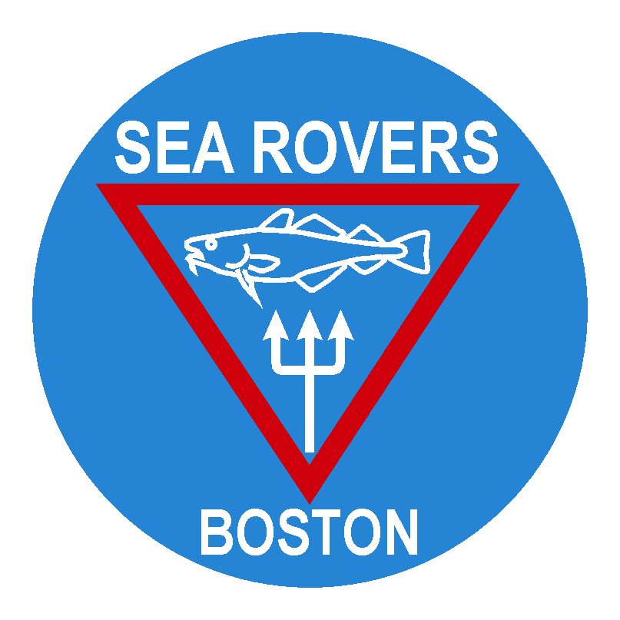
Boston Sea Rovers
Annual Summer Internship

RELEASE OF LIABILITY, WAIVER OF CLAIMS, EXPRESS ASSUMPTION OF RISK AND INDEMNITY AGREEMENT
PLE
ASE READ AND BE CERTAIN YOU UNDERSTAND THE IMPLICATIONS OF SIGNING
EXPRESS ASSUMPTION OF RISK ASSOCIATED WITH DIVING AND RELATED ACTIVITIES

I, _______________________________________________, do hereby affirm and acknowledge that I am fully aware of the inherent hazards and risks associated with all forms of diving. I understand that these risks can lead to severe injury and even loss of life and that diving operations may be conducted at a site that is remote from a recompression chamber and competent medical assistance. With this knowledge, I choose to proceed even in the absence of a recompression chamber and competent medical assistance. Additionally, I understand that there are also risks associated with dive travel, including, but not limited to the possible injury or loss of life as a result of a dive boat accident, as well as travel to and from dive sites. Despite the potential hazards and dangers associated with the activity of diving, I wish to proceed and I freely accept and expressly assume all risk, dangers and hazards that may arise from diving activities which could result in personal injury, loss of life and property damage to me.

RELEASE OF LIABILITY, WAIVER OF CLAIMS AND INDEMNITY AGREEMENT:

In consideration of being allowed to participate in all Internship activities as well as the use of any program-related facilities and equipment, I hereby agree as follows:

1. TO WAIVE AND RELEASE ANY AND ALL CLAIMS based upon negligence, active or passive with the exception of intentional, wanton or willful misconduct that I may have in the future against any of the following named persons or entities (hereafter referred to as Releasees):

- Boston Sea Rovers
- Boston Sea Rovers Annual Summer Committee and Coordinator
- Others as listed:___________________________________________________________________________________

________________________________________________________________________________________________

2. To release the releasees, their officers, board of directors, employees, representatives, agents and volunteers, from liability and responsibility, whatsoever, for any claims or causes of action that I, my estate, heirs executors or assigns may have for personal injury, property damage or wrongful death arising from all diving activities whether caused by active or passive negligence of the releasees or otherwise with the exception of gross negligence. By executing this document, I agree to hold the releasees harmless for any injury or loss of life, which may occur to me during diving activities and/or instruction as well as any and all other activities engaged in pursuant to the Boston Sea Rovers Annual Summer Internship (hereinafter “the Internship”. I understand that the entire range of activities in which I may engage as the recipient of the Internship are of an adventurous nature and it is my intention to waive any and all liability against the parties in paragraph 1 for injury and or death that may occur from the participation in these endeavors which by their nature pose serious risks both obvious and non-obvious.”.

3. By entering into this agreement, I am not relying on any oral or written representation or statements made by the releasees, other than what is set forth in this agreement. I further agree that this Agreement shall be governed by and interpreted in accordance with the laws of the State of Massachusetts, United States of America.

4. If any provision, section, subsection, clause or phrase of this release is found to be unenforceable or invalid, that portion shall be severed from this contract. The remainder of this contract will then be construed as though the unenforceable portion had never been contained in this document.

I hereby declare that I am of legal age and am competent to sign this Agreement or, if not, that my parent or legal guardian shall sign on my behalf, and that my parent or legal guardian is in complete understanding and concurrence with this agreement.

I HAVE READ THIS AGREEMENT, I UNDERSTAND IT, AND I AGREE TO BE BOUND BY IT.

Signature of Candidate _______________________________________________ Date ______________________

Witness (Name) ______________________________ Signature _________________________________________

Signature of Parent or Guardian If Participant Is a Minor, and by their signature they, on my behalf release all claims that both they and I have.

__________________________________________________________________________ Date _ _____________
(Parent Signature if participant is a minor)

